---TO INSTALL JENKINS

#!/bin/bash
sudo yum update -y
sudo wget -O /etc/yum.repos.d/jenkins.repo http://pkg.jenkins-ci.org/redhat/jenkins.repo
sudo rpm --import https://pkg.jenkins.io/redhat/jenkins.io.key
sudo yum install java-1.8.0 -y
sudo amazon-linux-extras install epel -y
sudo yum install jenkins -y
sudo yum install tree -y
sudo yum install git -y
sudo service jenkins start
sudo systemctl enable Jenkins

java1.8 version if we install Jenkins start will fail with error and then we can find the actual error with below comman
journalctl -xe
jenkins: invalid Java version: openjdk version "1.8.0_362"

To fix this uninstall this java version
sudo yum remove java*
Install below java.

sudo amazon-linux-extras install java-openjdk11

To access the Jenkins UI we need to add the customTCP port entry with 8080 as the port
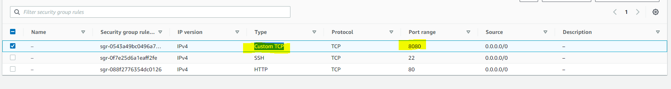

- All the operations of Jenkins are executed on linux machine with Jenkins user hence we need add the user to wheel group to provide wheel group.

sudo visudo -with this command /etc/sudoers file is opened for edit and we can see if we add user to wheel group which then can execute sudo command
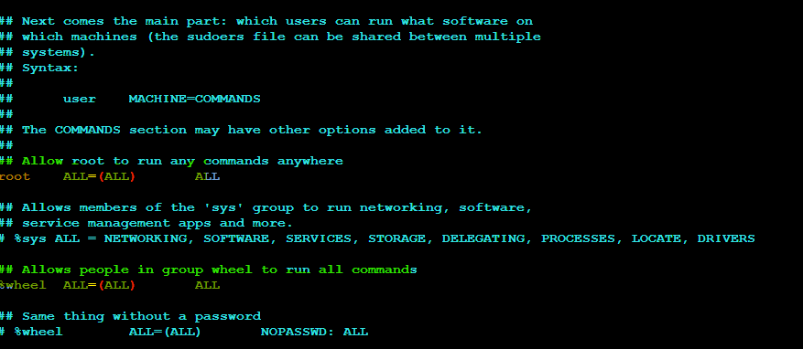

ENV VARIABLE FOR JENKINS – We can see username as Jenkins which means jobs will be executed with Jenkins user on linux machine
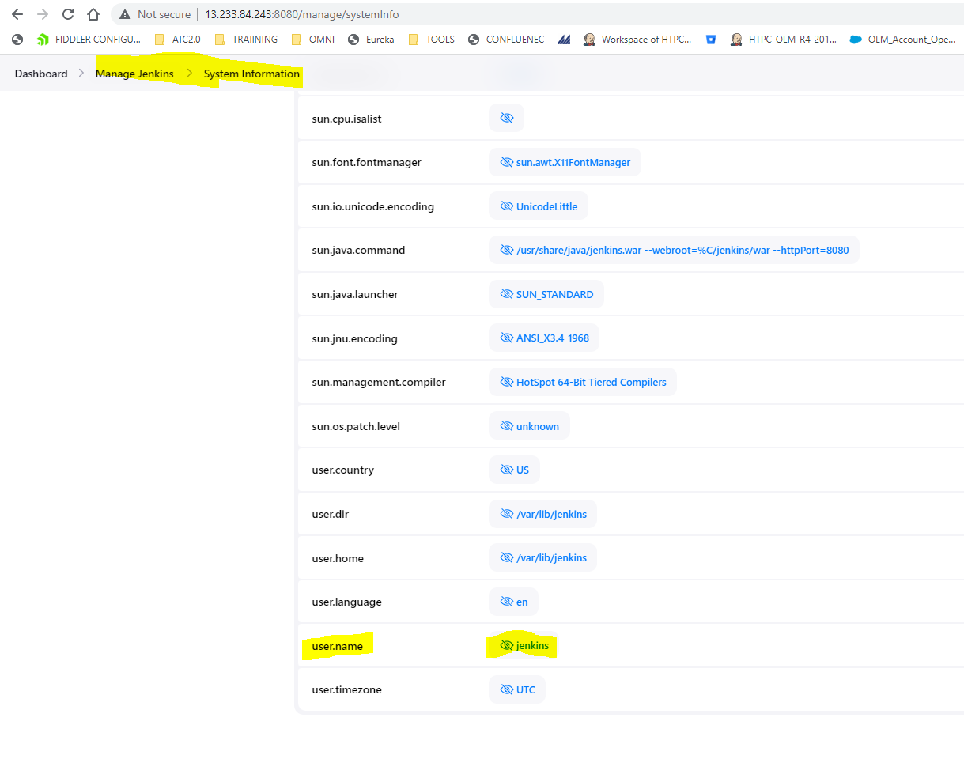
CLICK BUILD NOW AND LOOK AT THE CONSOLE OUTPUT OF BUILD NUMBER WE CAN SEE THE JOB SUBMITTED BY ADMIN USER BUT UNDERLYING USER WHICH IS PRESENT IN LINUX MACHINE IS Jenkins WHO WILL EXCEUTE THE SCRIPT.
Admin user does not exist in linux machine it is user to access Jenkins UI .
Jenkins is a linux user.
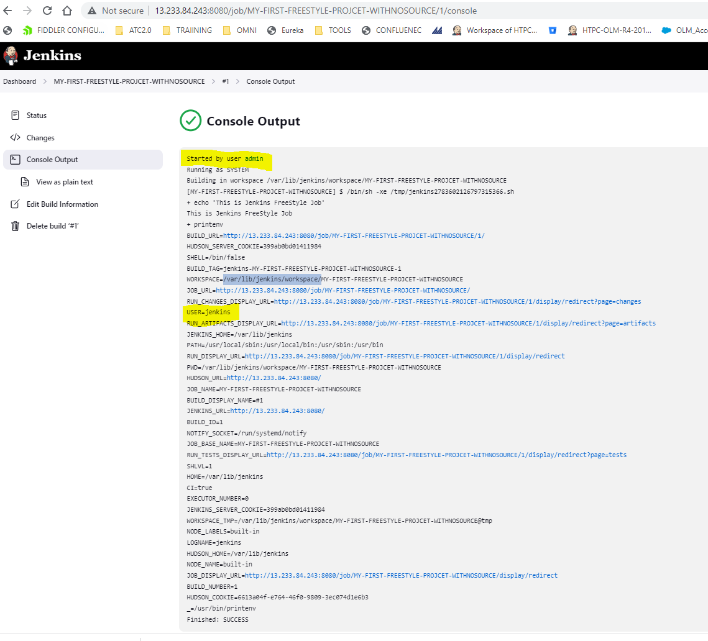

IF WE ADD THE PARAMETERS TO THE BUILD THEY WILL APPEAR AS ENVIROMENT VARIABLES.
AND WHEN JOB IS PARAMETEREZIED BUILD NOW BUTTON WILL BE CHANGED TO BUILD WITH PARAMETERS.
